Applicant’s Surname: |  |  |  |  |  | Applicant’s First Name:
Rank:  License Grade: |  |  |  |  | Date of birth:  Age: |  |  | Place of birth:
Home address:
Approximate Weight : Height :
Marital Status: | Single |  | Married |  | Next of kin:  Relationship: |  |  |  | Mobile:  NOK Mobile:  E-Mail:
DOCUMENTS |  |  |  |  | NUMBER |  | ISSUING AUTHORITY |  |  | Date Issued |  | Expiry Date
Passport
Seaman’s book
National License/Diploma
S T C W Endorsement/COC/ NCI
Flag Endorsement
Medical Fitness Certificate

PHOTO
TRAINING CERTIFICATES |  |  | YES | NO | ISSUING AUTHORITY |  | Date Issued | Expiry Date
BASIC FIRE-FIGHTING VI/1
PERSONAL SURVIVAL TECHNIQUES VI/1
PERSONAL SAFETY AND SOCIAL RESPONSIBILITIES VI/1
ELEMENTARY FIRST AID VI/1
SURVIVAL CRAFT & RESCUE BOATS VI/ 2
ADVANCED FIRE FIGHTING VI/ 3
MEDICAL FIRST AID VI/ 4.1
MEDICAL CARE VI/ 4.2
RADAR, ARPA, BRIDGE TEAMWORK A-I/12 A-I I/2
GMDSS (GO) IV/2
PREVENTION OF POLLUTION A-II/1 A-II/2
MARITIME ENGLISH A-II/1 A-II/2
TANKER FAMILIARIZATION V/ 1-1
SPECIALIZED OIL TANKER FAMILIARIZATION A- V/ 1-1.2
SPECIALIZED CHEMICAL TANKER FAMILIARIZATION A- V/ 1-1.3
ECDIS TRAINING A-II/1 A-II/2
SPECIFIC ECDIS
SECURITY AWARENESS VI/ 6
SHIP SECURITY OFFICER TRAINING VI/ 5
BRIDGE/ENGINE TEAM AND RESOURCE MANAGEMENT
SHIP HANDLING AND MANEUVERING SIMULATION A-II/1 A-II/2
ICE NAVIGATION TRAINING
RISK ASSESSMENT AND INCIDENT INVESTIGATION
SAFETY OFFICER TRAINING
IGF (AS APPLICABLE)
BTLGT (AS APPLICABLE)
OTHERS:
KNOWLEDGE OF ENGLISH*: GOOD  *All Officers must have good knowledge of English; Maritime English certification strongly preferred. |  |  |  |  |  | Attention : TO ALL APPLICANTS  RE : MEDICAL CONDITIONS NOT ACCEPTABLE  - HYPERTENSION WITH MEDICATION / DIABETES MELLITUS WITH MEDICATION /LOW HEMOGLOBIN  - CHRONIC HEPATITIS (NON-INFECTIOUS/ HEPA B POSITIVE-HEALTHY CARRIER / ISHIHARA DEFECTIVE  - MILD HEARING LOSS/GALLSTONES AND KIDNEY STONES /ANY HEART CONDITION REQUIRING MEDICATION  - CYST EVEN NO SURGICAL INTERVENTION/ANY PREVIOUS MEDICAL HISTORY THAT CONSTITUTED ILLNESS  _______________________________________ _____________________________________________  Date of Last Medical Clinic Of Last Medical Crew Signature Above Printed Name
VETTING EXPERIENCE: YES
USA TRANSIT VISA :
SCHENGEN VISA:

SEAFARER’S RECORD APPLICATION FORM
PREVIOUS SEA SERVICE - MINIMUM LAST FIVE YEARS

COMPANY | VESSEL | RANK | TYPE | FLAG | DWT | ENGINE TYPE | FROM | TO | REASON FOR SIGNING OFF

MASTER / OFFICER SUPPLEMENT
APPLICANT’S SIGNATURE:

DATE:
RANK
TOTAL YEARS IN RANK
TOTAL YEARS WITH OPERATOR |  | 0
TOTAL YEARS ON THIS TYPE OF TANKER | (as applicable)
TOTAL YEARS ON ALL TYPES OF TANKERS | (as applicable)

(use 1 decimal i.e., 2.4 yrs)
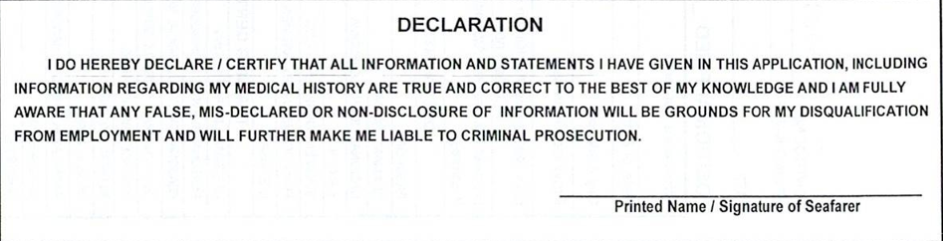

Actual sea service
Calendar years
Actual sea service
Actual sea service
Actual sea service

FOR CAPITAL SHIPMANNING PHILS INC. RECRUITMENT DEPT USE ONLY
PROPOSED BY MANNING OFFICE/AGENT: | DATE REVIEWED & APPROVED FOR INITIAL PROCESSING:

